**LIT TRAINING**

**Batch Name : SAP ABAP -25                                                            DAY 3 ASSIGNMENT**

**EMPLOYEE ID – 46247689                                                                DATE : 30th September 2022**

**Q-1: Create a Global class ZGET_MATERIALS. Method LIST_MATERIALS will belong to this class which will take material type as an input and will furnish a list of material codes and their descriptions belonging to that material type.**

**There will be a parameter for material type in the selection screen. Enter a valid value and get the list of material codes and descriptions.**

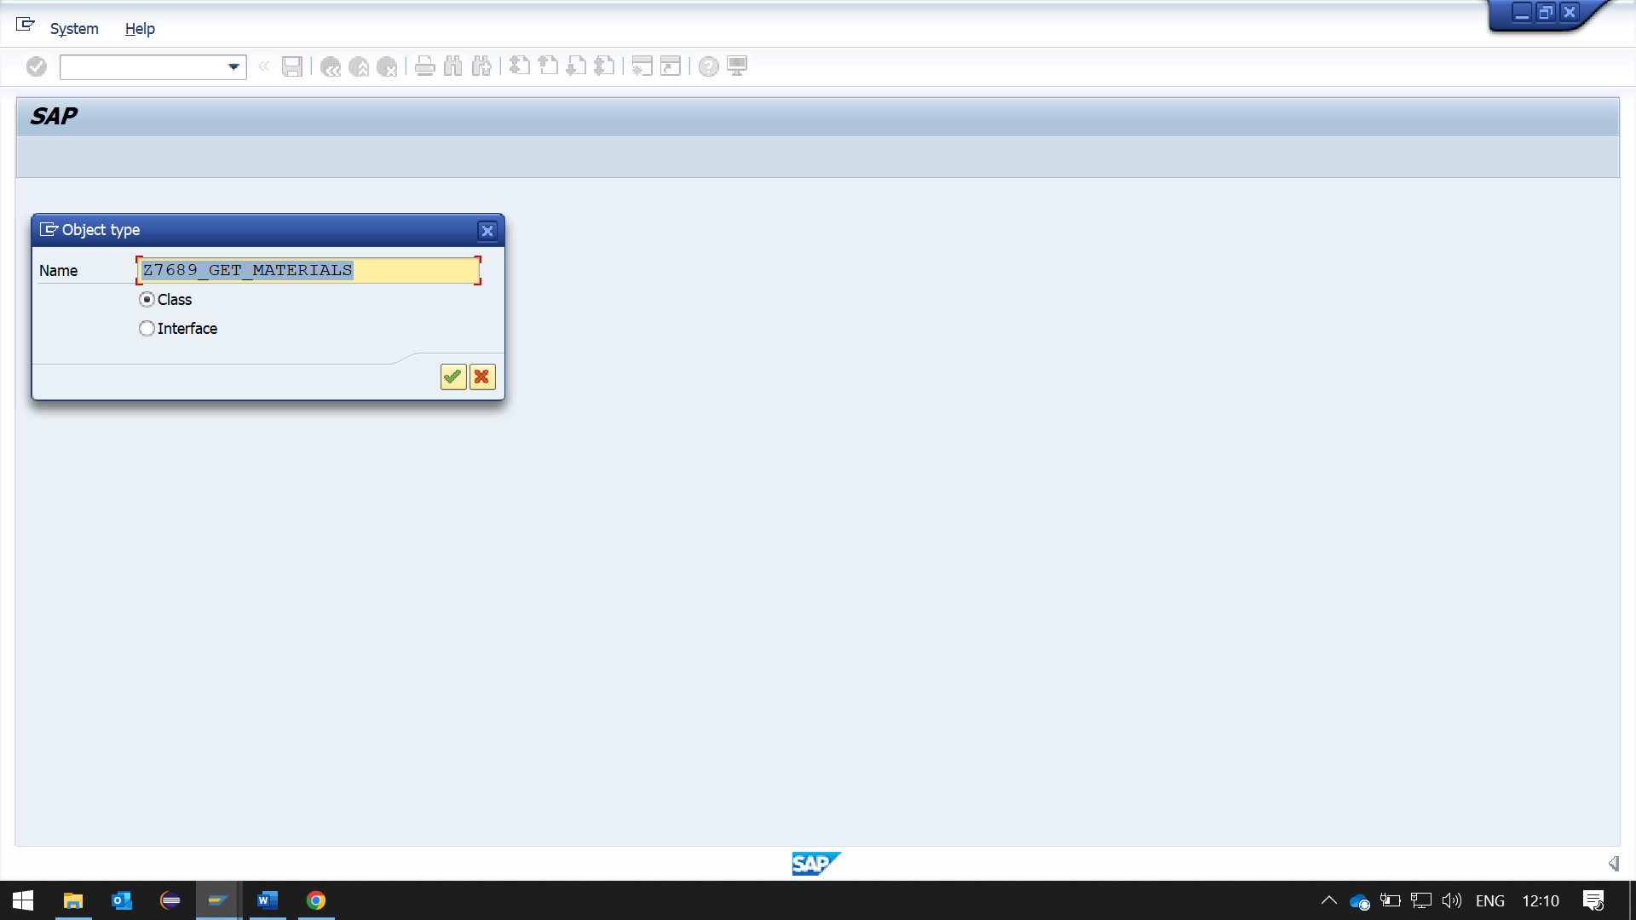

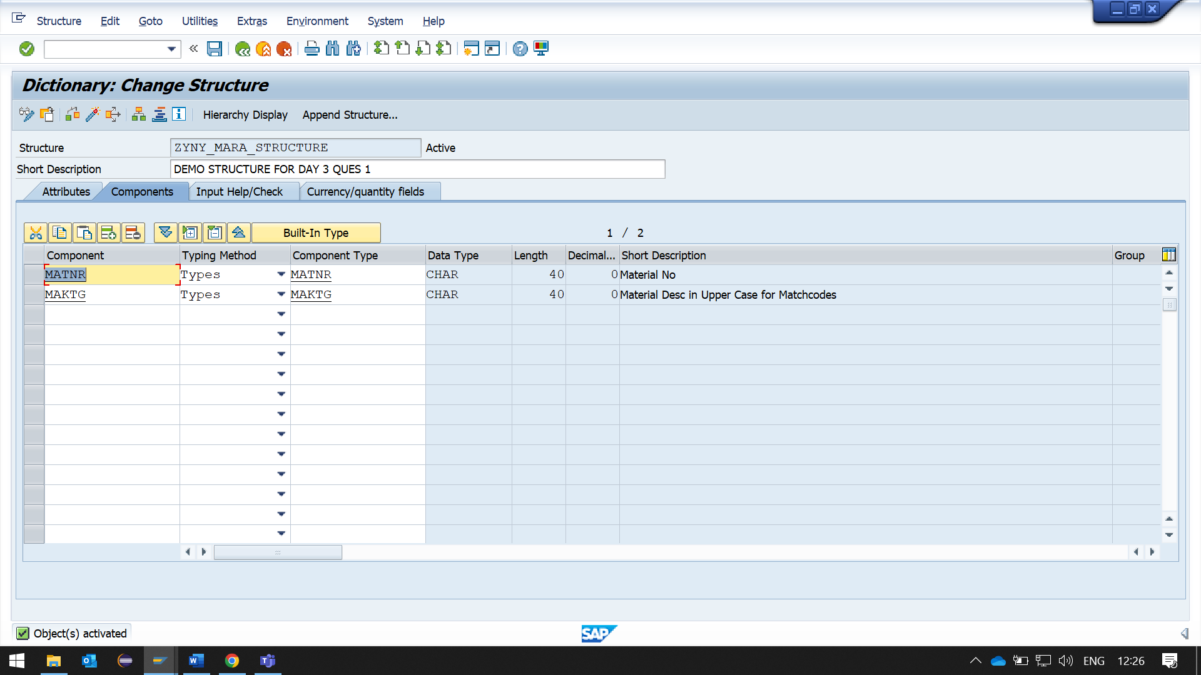

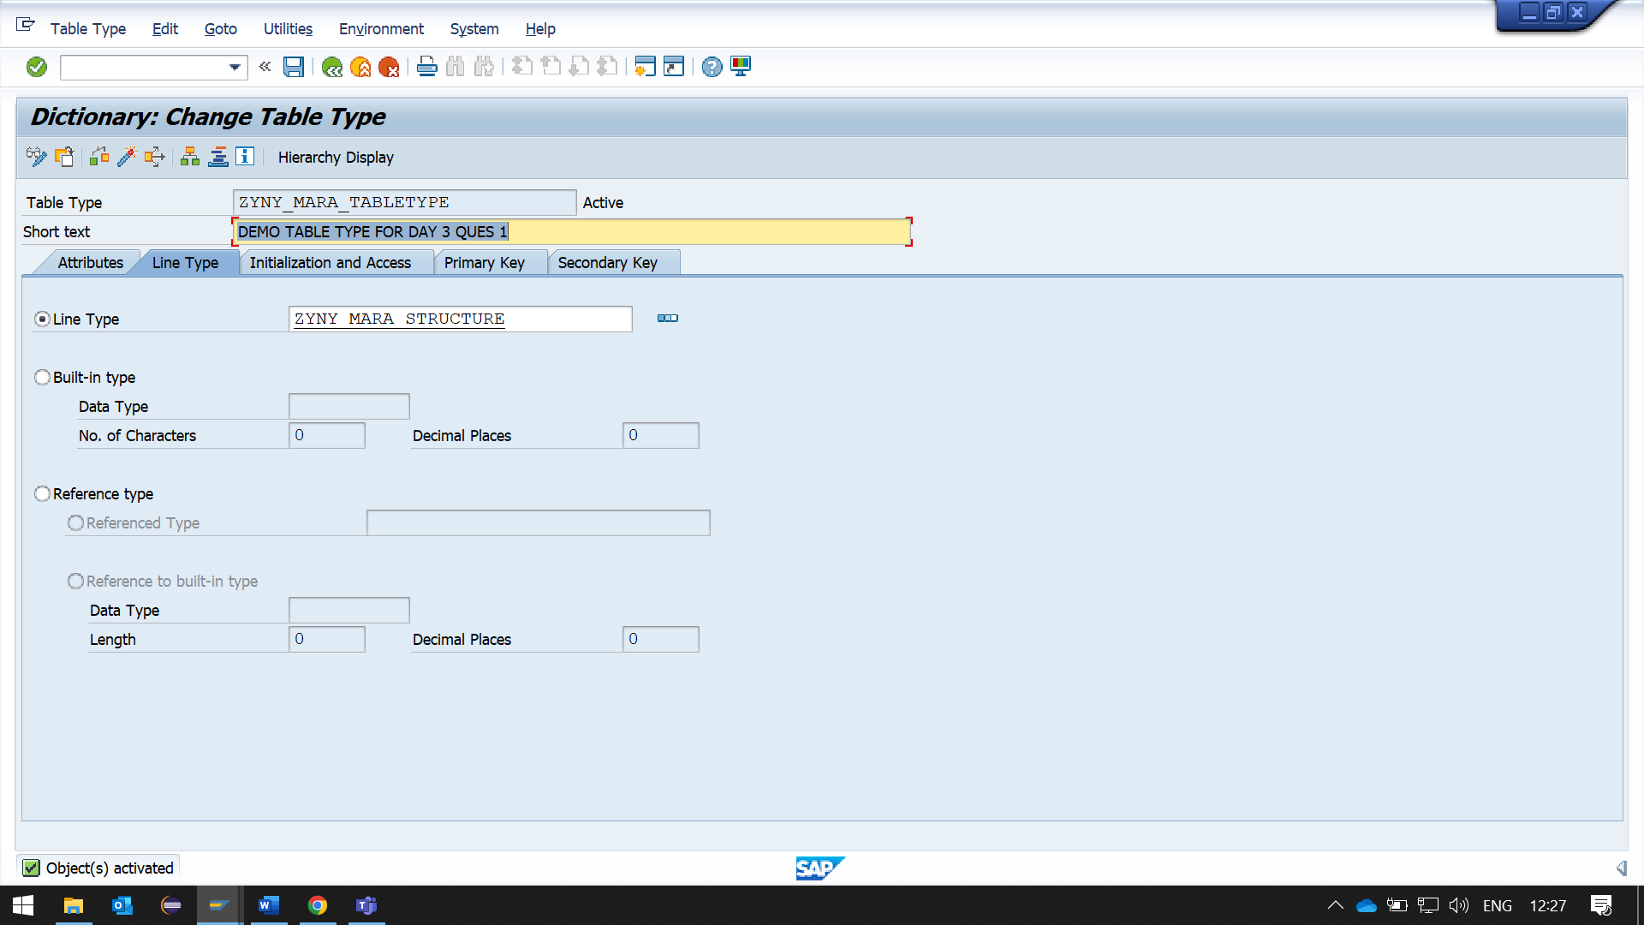

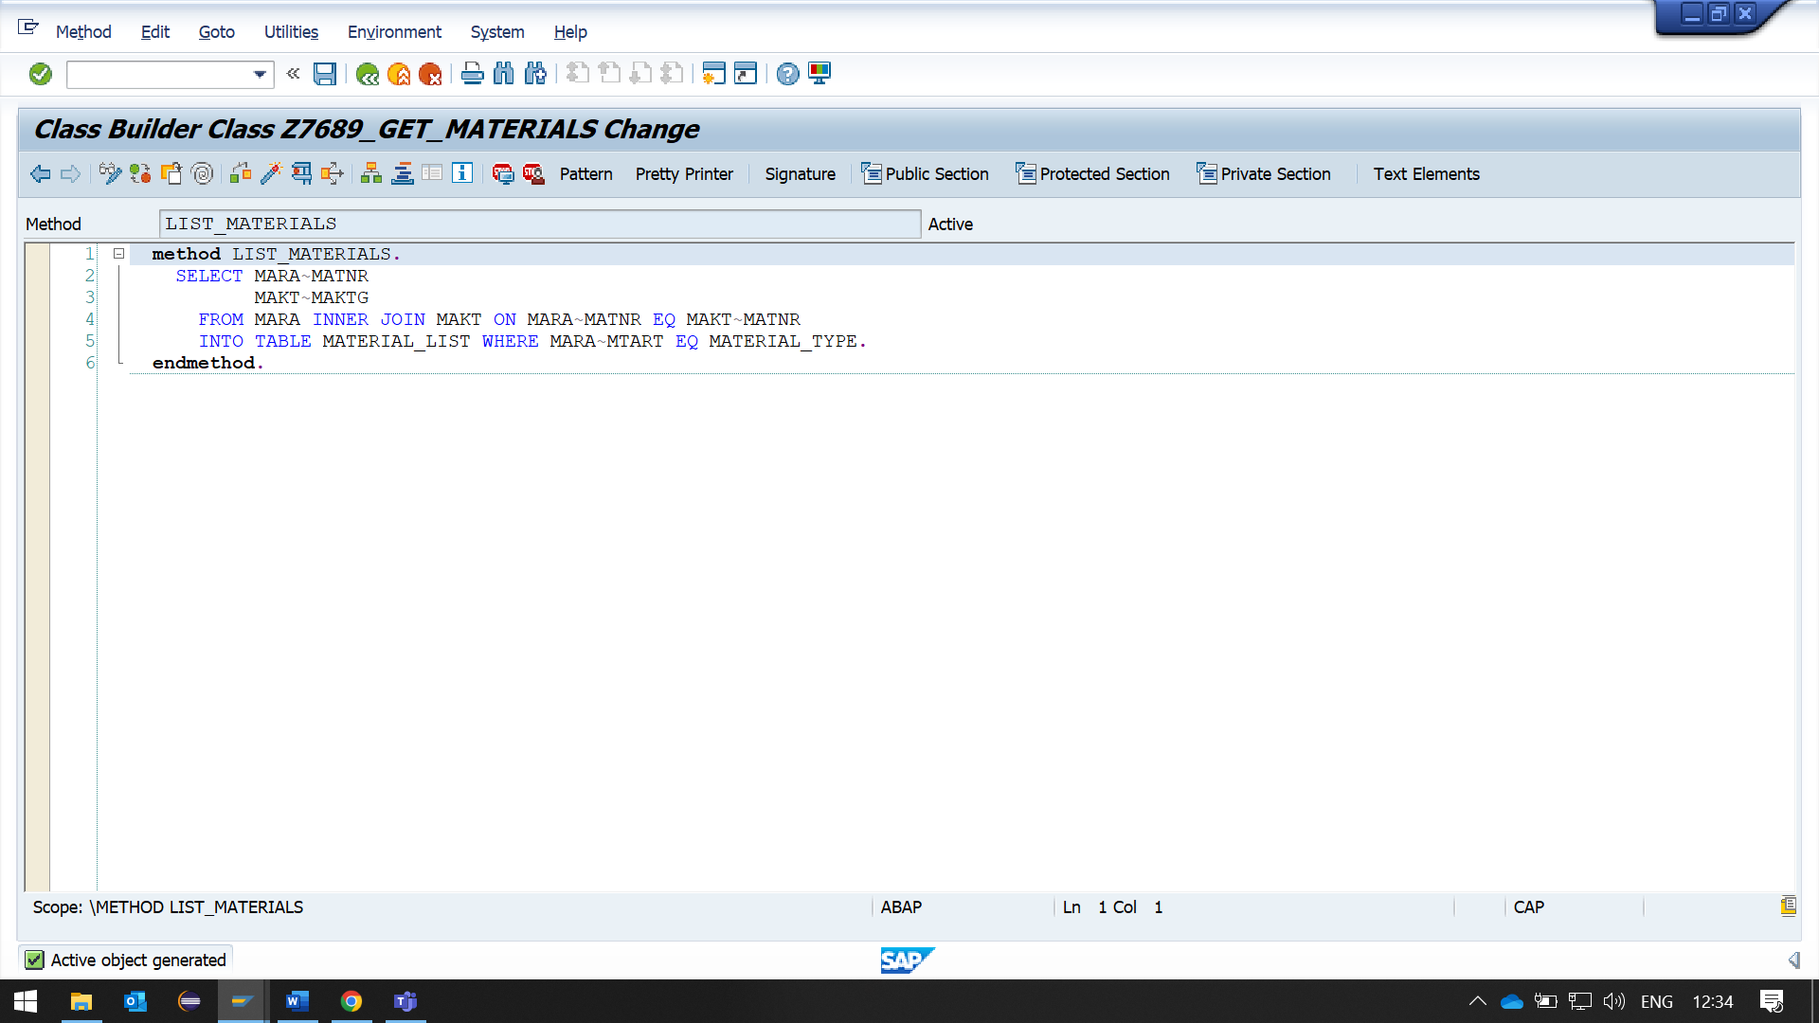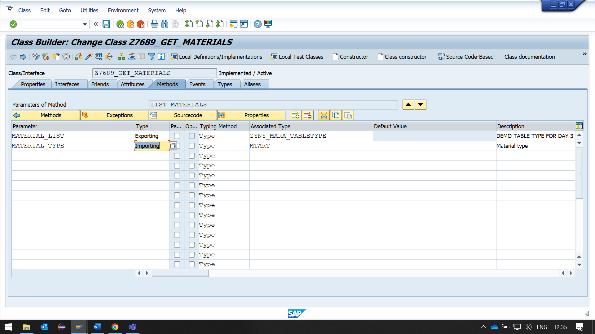

**REPORT:**

REPORT ZYNY_ABHAY_REPORT7.  
  
TABLES: MARA, MAKT.  
  
*\*&---------------------------------------------------------------------\**  
*\*& DATA DECLARATION*  
*\*&---------------------------------------------------------------------\**  
DATA: IT_TAB TYPE TABLE OF ZYNY_MARA_STRUCTURE,  
      WA_TAB TYPE ZYNY_MARA_STRUCTURE.  
  
DATA:OBJ TYPE REF TO Z7689_GET_MATERIALS.  
  
PARAMETERS: MTART TYPE MARA-MTART DEFAULT 'FERT'.  
  
*\*&---------------------------------------------------------------------\**  
*\*& START-OF-SELECTION*  
*\*&---------------------------------------------------------------------\**  
START-OF-SELECTION.  
  
*\*&---------------------------------------------------------------------\**  
*\*& CREATE OBJECT*  
*\*&---------------------------------------------------------------------\**  
  CREATE OBJECT OBJ.  
  
  
*\*&---------------------------------------------------------------------\**  
*\*& CALL METHOD LIST_MATERIALS*  
*\*&---------------------------------------------------------------------\**  
  CALL METHOD OBJ->LIST_MATERIALS  
    EXPORTING  
      material_type = MTART  
    IMPORTING  
      material_list = IT_TAB  
    EXCEPTIONS  
      exception     = 1  
      others        = 2.  
  
*\*&---------------------------------------------------------------------\**  
*\*& EXCEPTION HANDLING*  
*\*&---------------------------------------------------------------------\**  
  IF sy-subrc = 1.  
    MESSAGE E005(ZYNY_ABHAY_MESSAGE).  
  ELSEIF SY-SUBRC = 2.  
    MESSAGE E001(ZYNY_ABHAY_MESSAGE).  
  ELSE.

END-OF-SELECTION.  
*\*&---------------------------------------------------------------------\**  
*\*& PRINTING DATA*  
*\*&---------------------------------------------------------------------\**  
  WRITE: 'MATERIAL CODE' ,30 'MATERIAL TYPE'.  
    ULINE.  
    LOOP AT IT_TAB INTO WA_TAB.  
  
      WRITE:/ WA_TAB-MATNR, 30 WA_TAB-MAKTG.  
    ENDLOOP.  
  ENDIF.

**OUTPUT:**

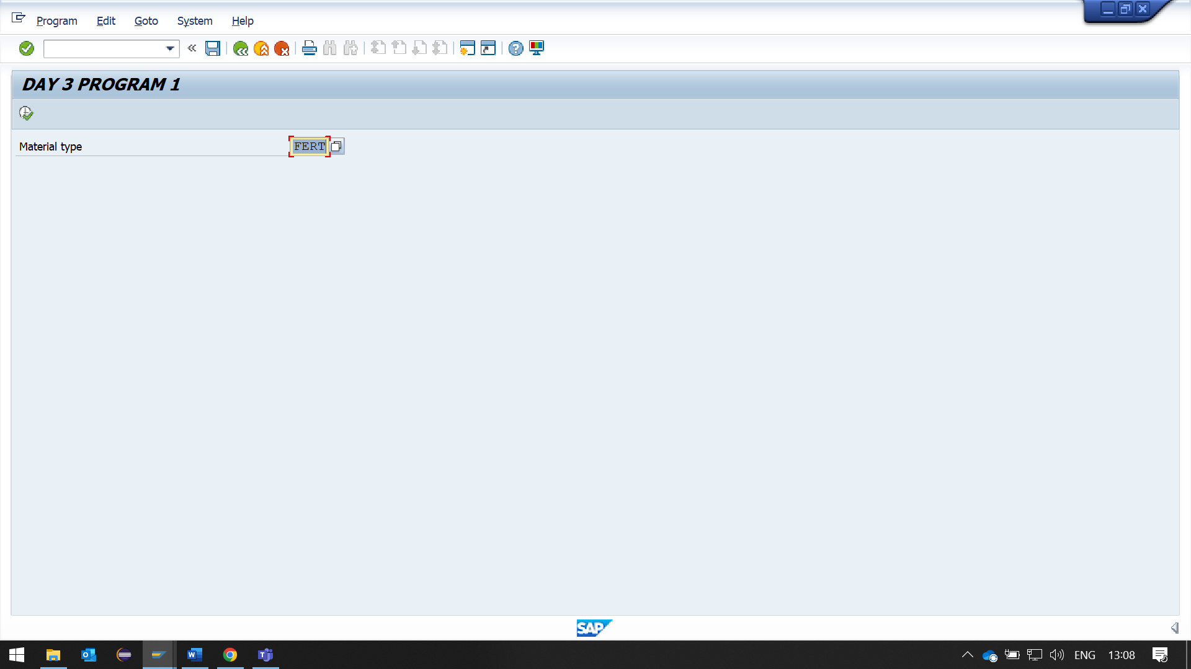

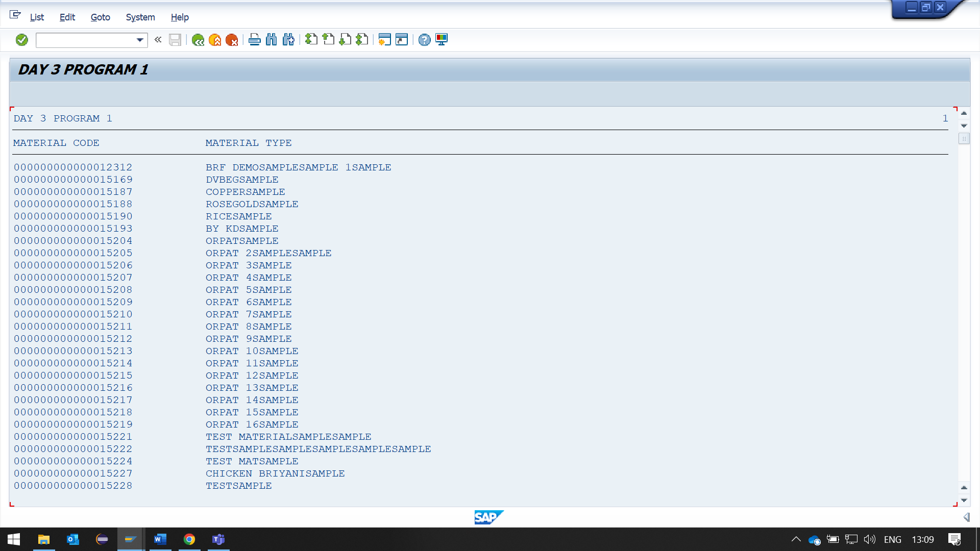

**Q-2: Create a program that contains a method TAX_CALC belonging to the class ZCTAX. It receives GRADE as IMPORTING parameter and SALARY as CHANGING parameter. Based on the grade, the EXPORTING parameter ITAX is calculated and the CHANGING parameter, SALARY is modified by deducting tax from it.**

**if Grade = 'A01' then Income Tax should be 0.2**

**if Grade = 'A02' then Income Tax should be 0.1.**

**Output: Before method call, salary and tax are 30,000.00 0.00**

**After method call, salary and tax are 24,000.00 6,000.00**

**REPORT:**

*\*&---------------------------------------------------------------------\**  
*\*& Report ZYNY_ABHAY_REPORT8*  
*\*&---------------------------------------------------------------------\**  
REPORT ZYNY_ABHAY_REPORT8.  
  
*\*&---------------------------------------------------------------------\**  
*\*& CLASS DEFINITION*  
*\*&---------------------------------------------------------------------\**  
CLASS ZCTAX DEFINITION.  
  PUBLIC SECTION.  
    METHODS : TAX_CALC  
      IMPORTING grade  TYPE C  
      EXPORTING itax   TYPE P  
      CHANGING  salary TYPE P .  
ENDCLASS.  
  
*\*&---------------------------------------------------------------------\**  
*\*& CLASS IMPLEMENTATION*  
*\*&---------------------------------------------------------------------\**  
CLASS ZCTAX IMPLEMENTATION.  
  METHOD : TAX_CALC.  
    CASE grade.  
      WHEN 'A01'.  
        itax = salary * '0.2'.  
      WHEN 'A02'.  
        itax = salary * '0.1'.  
    ENDCASE.  
    salary = salary - itax.  
  ENDMETHOD.  
ENDCLASS.  
  
*\*&---------------------------------------------------------------------\**  
*\*& DATA DECLARATION*  
*\*&---------------------------------------------------------------------\**  
DATA : tax type p decimals 2 .  
DATA : OBJ1 TYPE REF TO ZCTAX.  
  
PARAMETERS: W_salary type p decimals 2 DEFAULT '30000.00'.  
  
*\*&---------------------------------------------------------------------\**  
*\*& START-OF-SELECTION*  
*\*&---------------------------------------------------------------------\**  
START-OF-SELECTION.  
  
*\* CREATE OBJECT*  
  CREATE OBJECT : OBJ1.  
  tax = 0 .  
  write:/5 'Before method call, salary and tax are ' , w_salary , tax .  
  
*\* CALL METHOD TAX_CALC*  
  CALL METHOD OBJ1->TAX_CALC  
    EXPORTING  
      grade  = 'A01'  
    IMPORTING  
      itax   = tax  
    CHANGING  
      salary = w_salary.  
  
  write:/5 'After method call, salary and tax are' ,  
  w_salary ,  
  tax .

**OUTPUT:**

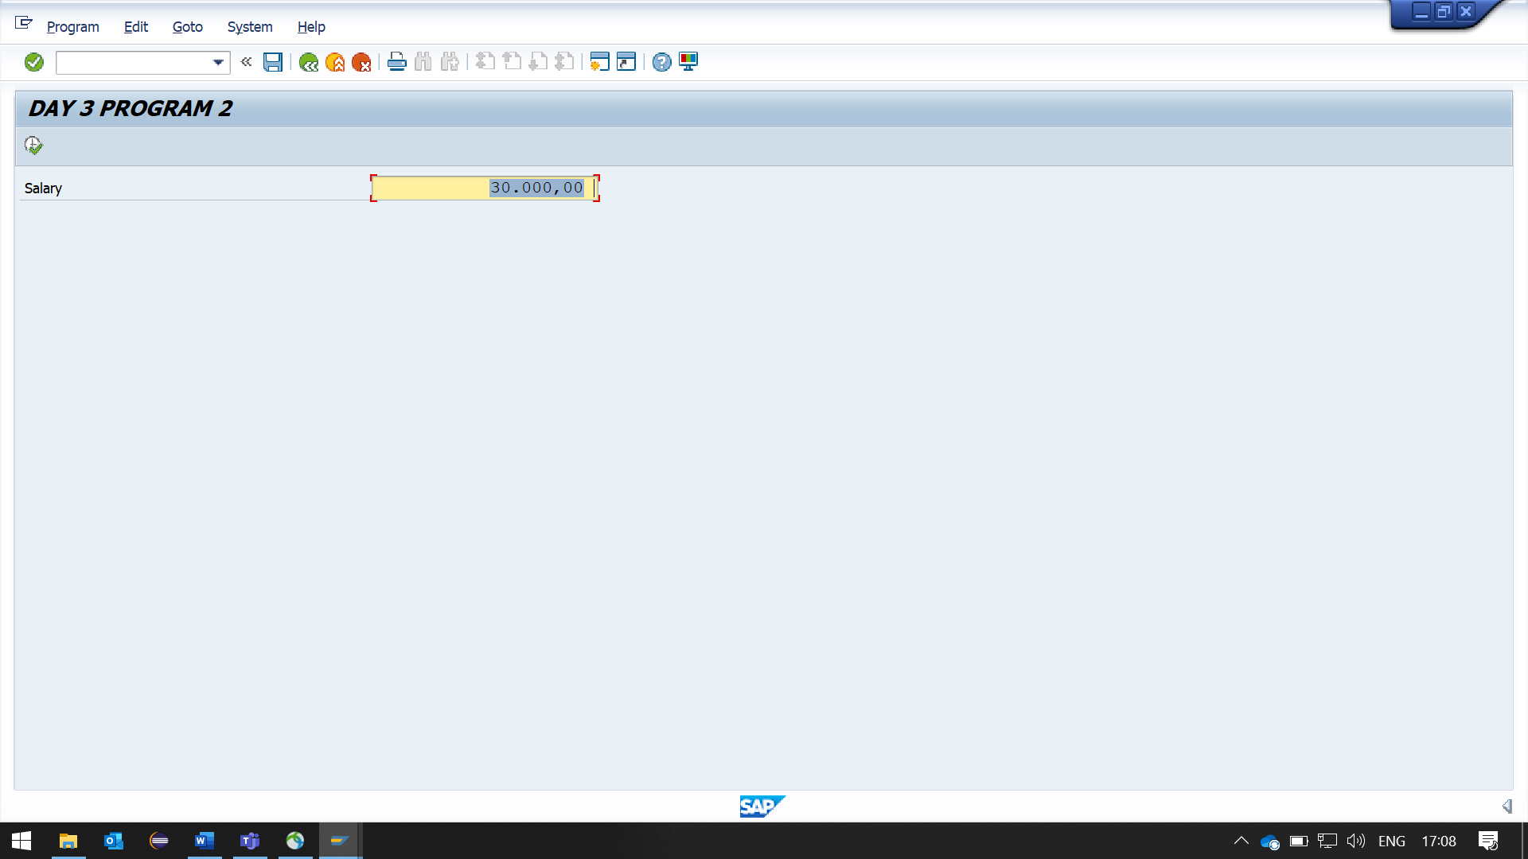

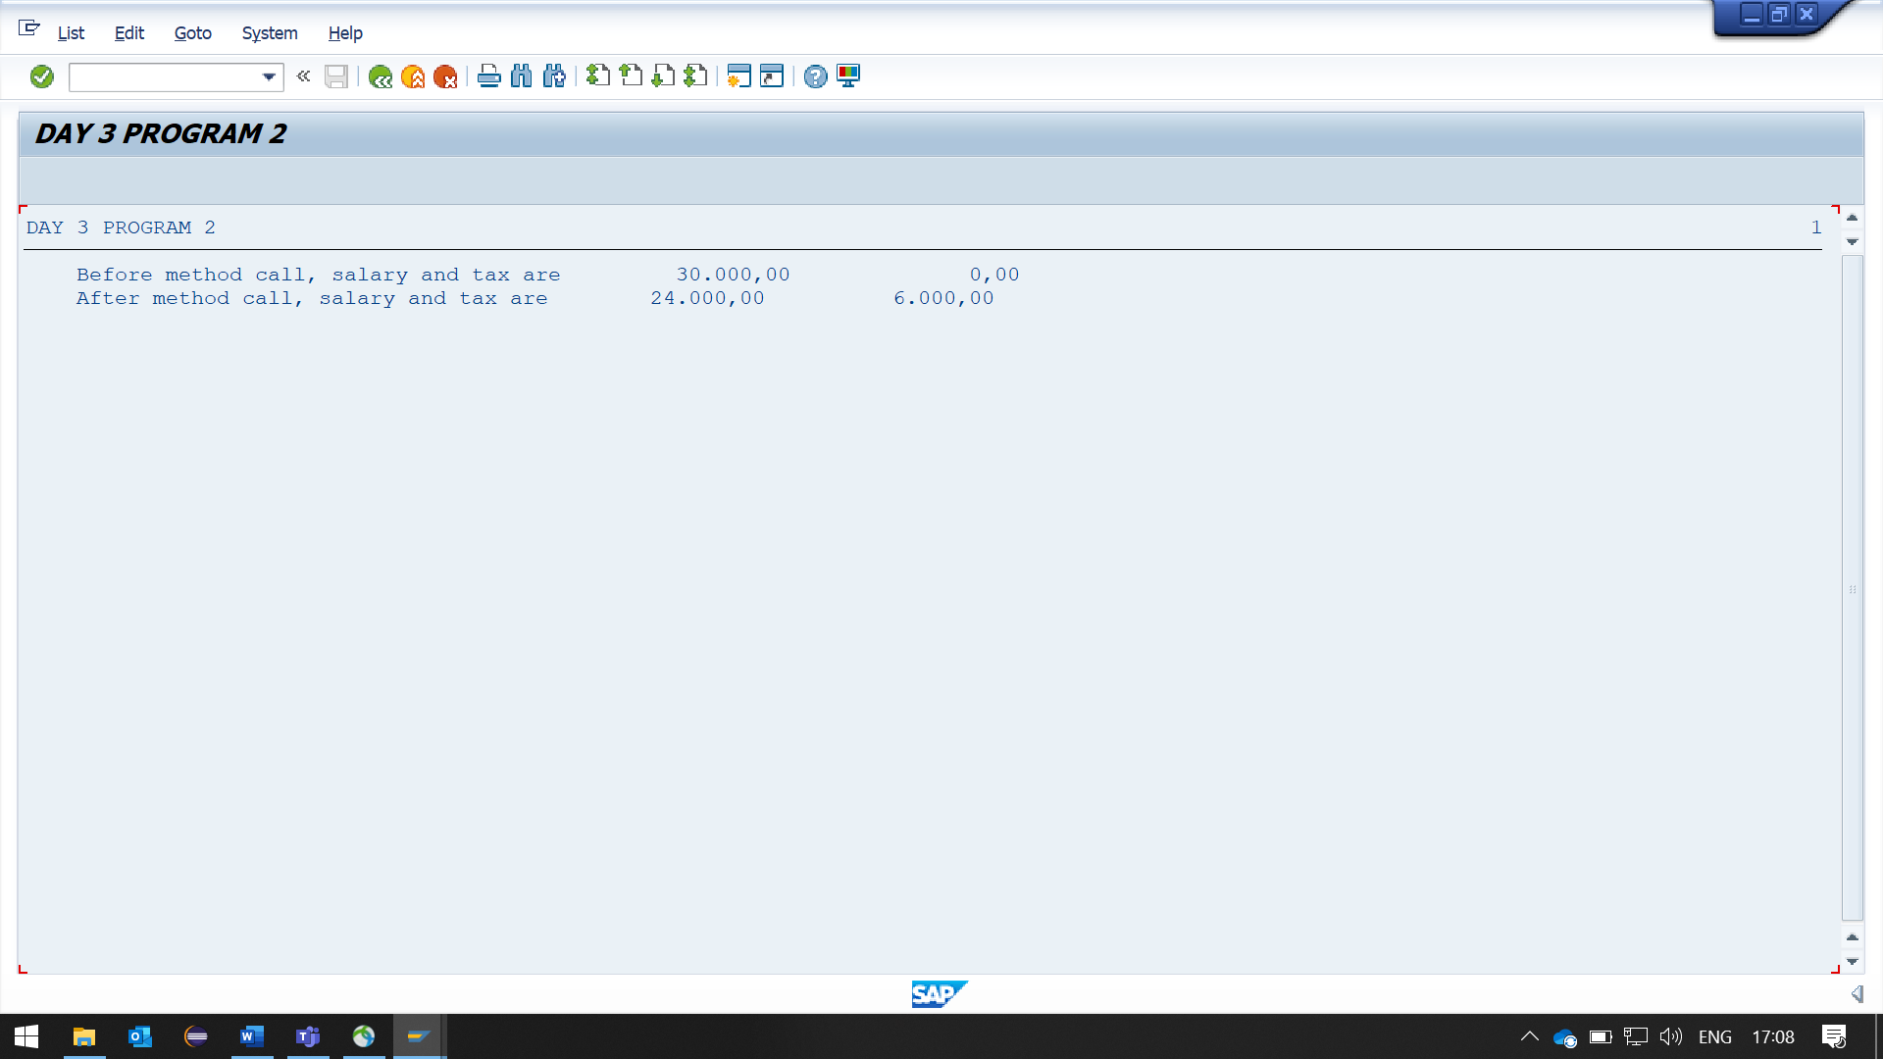

**Q-3: Create a report Using Class CL_GUI_ALV_GRID.**

**Selection Screen Material Input.**

**Second Screen Output: below Fields**

**VBELN ERDAT ERZET ERNAM ANGDT BNDDT AUDAT VBTYP TRVOG.**

**Use Double Click Event on VBELN field. It will Redirect to Transaction VA03.**

**(Use Local Class & Method for Modularization)**

**REPORT:**

*\*&---------------------------------------------------------------------\**  
*\*& Report ZYNY_ABHAY_REPORT9*  
*\*&---------------------------------------------------------------------\**  
REPORT ZYNY_ABHAY_REPORT9.  
  
*\*&---------------------------------------------------------------------\**  
*\*& CLASS DEFINITION*  
*\*&---------------------------------------------------------------------\**  
CLASS lcl_vbak DEFINITION.  
  PUBLIC SECTION.  
  
*\*METHODS*  
    METHODS: get_data,  
      build_fieldcatlog,  
      display_alv.  
  
*\* STATIC VARIABLES*  
    CLASS-DATA: gt_vbak TYPE TABLE OF ZYNY_VBAK_STRUCTURE,  
                gt_fcat TYPE lvc_t_fcat,  
                wa_vbak type ZYNY_VBAK_STRUCTURE.  
  
*\* CLASS METHODS*  
    CLASS-METHODS: handle_double_click  
               FOR EVENT double_click OF cl_gui_alv_grid IMPORTING e_row .  
ENDCLASS.  
  
*\*&---------------------------------------------------------------------\**  
*\*& CLASS IMPLEMENTATION*  
*\*&---------------------------------------------------------------------\**  
CLASS lcl_vbak IMPLEMENTATION.  
  
  METHOD get_data.  
  
    SELECT vbeln,erdat,erzet,ernam,audat,vbtyp,trvog FROM VBAK  
    INTO CORRESPONDING FIELDS OF TABLE @gt_vbak.  
  
  ENDMETHOD.  
  
*\* HANDLER FOR DOUBLE CLICK*  
  METHOD handle_double_click.  
  
    READ TABLE gt_vbak INTO wa_vbak INDEX e_row.  
    SET PARAMETER ID 'AUN' FIELD wa_vbak-vbeln.  
    CALL TRANSACTION 'VA03' without authority-check.  
  
  ENDMETHOD.  
  
*\* Build FieldCatlog*  
  METHOD build_fieldcatlog.  
    CALL FUNCTION 'LVC_FIELDCATALOG_MERGE'  
      EXPORTING  
        i_structure_name       = 'ZYNY_VBAK_STRUCTURE'  
      CHANGING  
        ct_fieldcat            = gt_fcat  
      EXCEPTIONS  
        inconsistent_interface = 1  
        program_error          = 2  
        OTHERS                 = 3.  
    IF sy-subrc = 1.  
      MESSAGE E005(ZYNY_ABHAY_MESSAGE).  
    ELSEIF SY-SUBRC = 2.  
      MESSAGE E000(ZYNY_ABHAY_MESSAGE).  
    ELSEIF SY-SUBRC = 3.  
      MESSAGE E001(ZYNY_ABHAY_MESSAGE).  
    ENDIF.  
  ENDMETHOD.  
  
  METHOD display_alv.  
*\*    PRINTING DATA*  
    CALL SCREEN 100.  
  ENDMETHOD.  
ENDCLASS.                    *"lcl_vbak IMPLEMENTATION*  
  
*\*&---------------------------------------------------------------------\**  
*\*& DATA DECLARATION*  
*\*&---------------------------------------------------------------------\**  
DATA: lo_vbak          TYPE REF TO lcl_vbak,  
      lo_container_100 TYPE REF TO cl_gui_custom_container,  
      lo_grid          TYPE REF TO cl_gui_alv_grid.  
  
*\*&---------------------------------------------------------------------\**  
*\*& PARAMETERS DECLARATION*  
*\*&---------------------------------------------------------------------\**  
parameters: vbeln type vbak-vbeln default '1'.  
  
*\*&---------------------------------------------------------------------\**  
*\*& START-OF-SELECTION*  
*\*&---------------------------------------------------------------------\**  
START-OF-SELECTION.  
  
*\* Create instance for the local class*  
  CREATE OBJECT lo_vbak.  
  
*\* Get the SFLIGHT table data*  
  lo_vbak->get_data( ).  
  
*\*  Create container instance*  
  CREATE OBJECT lo_container_100  
    EXPORTING  
      container_name = 'ALV'.  
  
*\*  Create ALV grid instance by using the container instance*  
  CREATE OBJECT lo_grid  
    EXPORTING  
      i_parent = lo_container_100.  
  
  SET HANDLER lcl_vbak=>handle_double_click FOR lo_grid.  
  
*\* Build Field Catlog*  
  lo_vbak->build_fieldcatlog( ).  
  
*\*  Call the ALV*  
  CALL METHOD lo_grid->set_table_for_first_display  
    CHANGING  
      it_outtab                     = lo_vbak->gt_vbak  
      it_fieldcatalog               = lo_vbak->gt_fcat   
    EXCEPTIONS  
      invalid_parameter_combination = 1  
      program_error                 = 2  
      too_many_lines                = 3  
      OTHERS                        = 4.  
  IF sy-subrc = 1.  
    MESSAGE E006(ZYNY_ABHAY_MESSAGE).  
  ELSEIF sy-subrc = 2.  
    MESSAGE E000(ZYNY_ABHAY_MESSAGE).  
  ELSEIF sy-subrc = 3.  
    MESSAGE E007(ZYNY_ABHAY_MESSAGE).  
  ELSEIF sy-subrc = 4.  
    MESSAGE E001(ZYNY_ABHAY_MESSAGE).  
  ENDIF.  
  
*\* Display the ALV*  
  lo_vbak->display_alv( ).  
  
MODULE user_command_0100 INPUT.  
  case sy-ucomm.  
    when 'BACK'.  
      LEAVE TO SCREEN 0.  
  endcase.  
ENDMODULE.

**OUTPUT:**

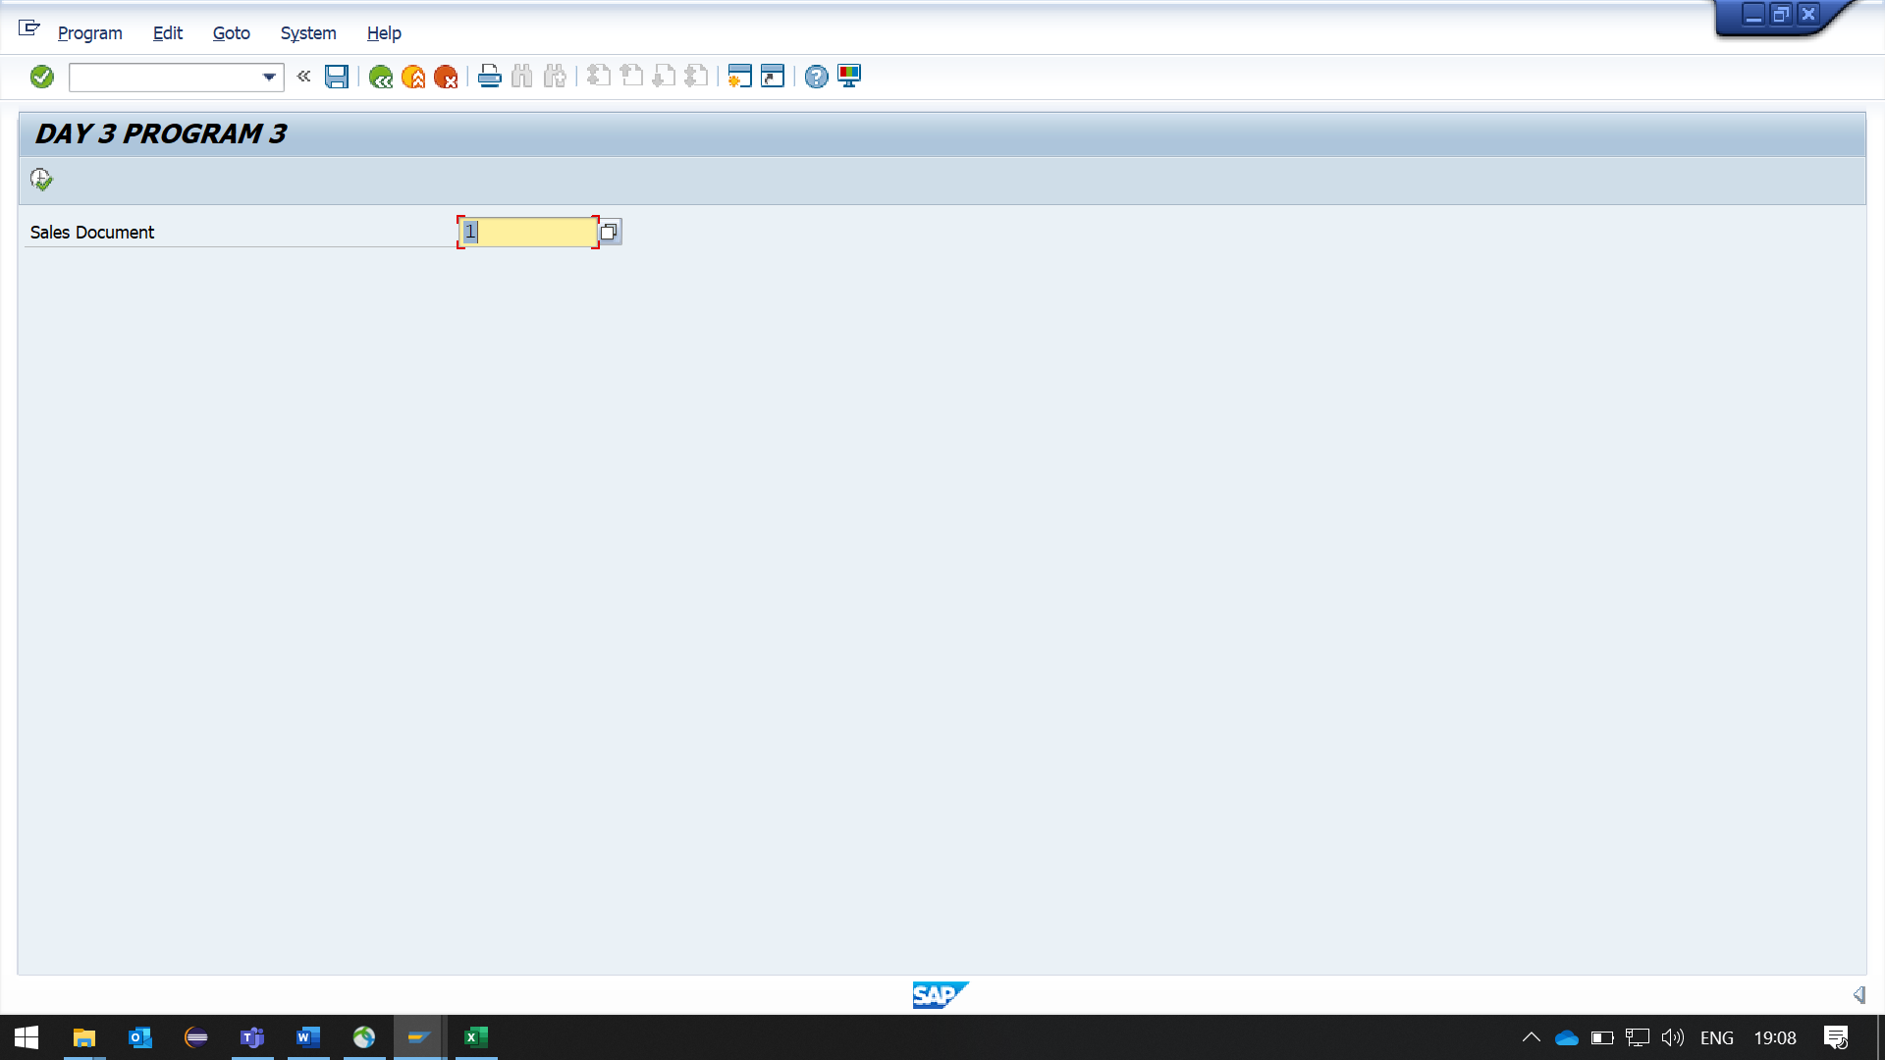

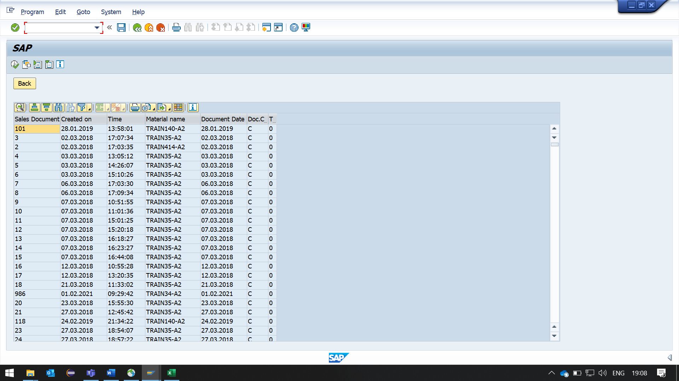

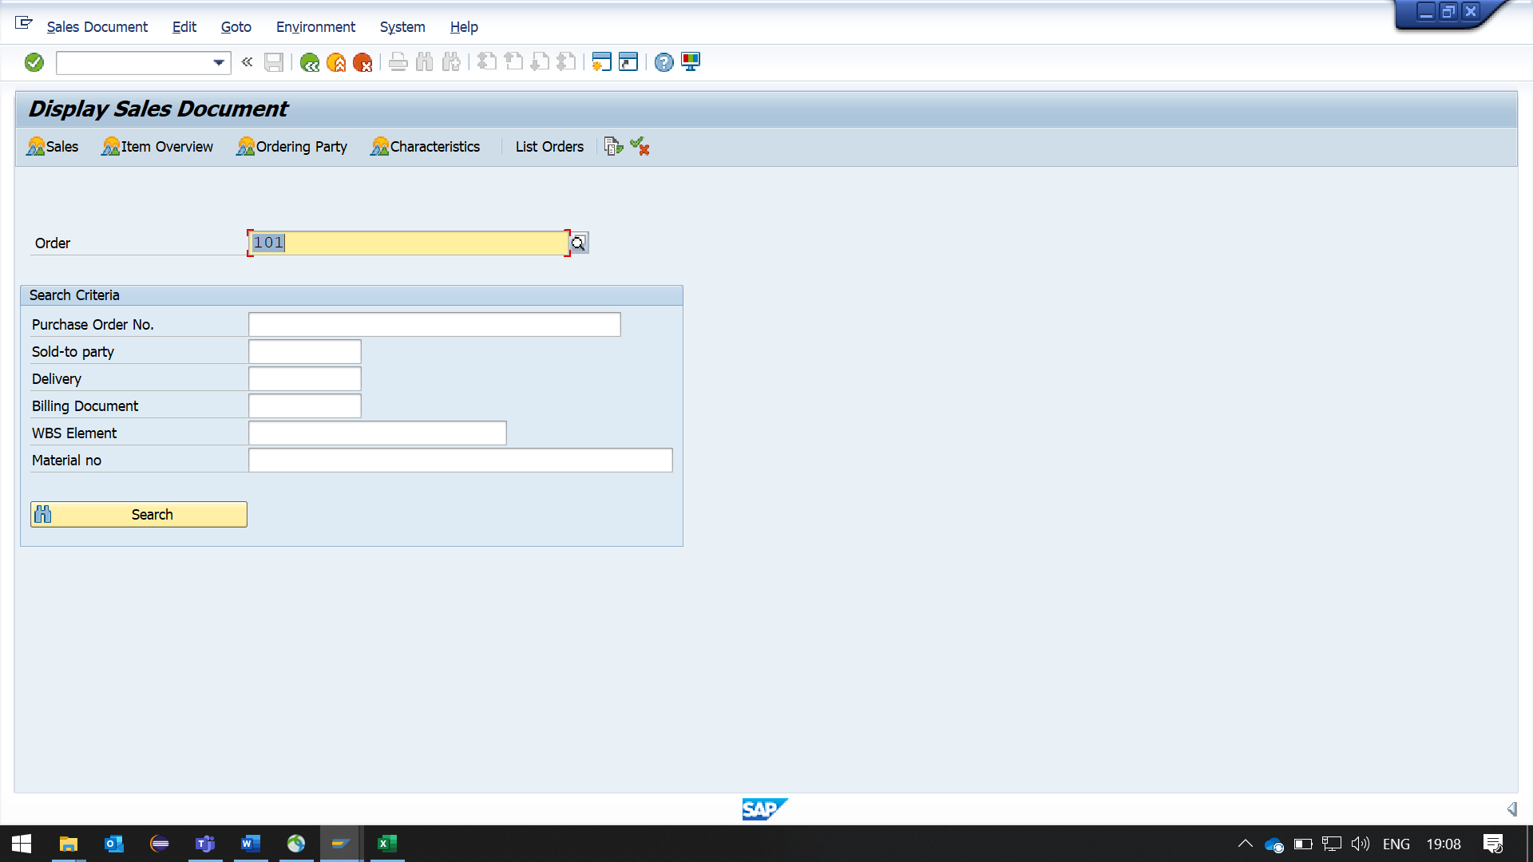

**Optional: -**

**Q-4: Create a report Using CL_SALV_TABLE.**

**Display Data of SFLIGHT~CARRID SFLIGHT~CONNID**

**SFLIGHT~PLANETYPE SBOOK~FLDATE**

**SBOOK~BOOKID SBOOK~SMOKER**

**SCARR~CARRNAME**

**Colour (Yellow) the row of AlV output if SMOKER = 'X'.**

**REPORT:**

*\*&---------------------------------------------------------------------\**  
*\*& Report ZYNY_ABHAY_REPORT10*  
*\*&---------------------------------------------------------------------\**  
REPORT ZYNY_ABHAY_REPORT10.  
  
*\*&---------------------------------------------------------------------\**  
*\*& TYPE DECLARATION*  
*\*&---------------------------------------------------------------------\**  
TYPES:BEGIN OF ty_tab,  
        carrid    TYPE   S_CARR_ID,  
        connid    TYPE   s_CONN_ID,  
        planetype TYPE s_planetyE,  
        fldate    TYPE   S_date,  
        bookid    TYPE   S_book_id,  
        smoker    TYPE   S_smoker,  
        carrname  TYPE S_carrname,  
        COLOR     TYPE LVC_T_SCOL,  
      END OF ty_tab.  
  
*\*&---------------------------------------------------------------------\**  
*\*& DATA DECLARATION*  
*\*&---------------------------------------------------------------------\**  
DATA: it_tab   TYPE TABLE OF ty_tab,  
      wa_tab   type ty_tab,  
      LS_COLOR TYPE LVC_S_SCOL,  
      alv      TYPE REF TO cl_salv_table.  
  
DATA orf_1 TYPE REF TO cx_root.*"Abstract Superclass for All Global Exceptions*  
  
*\*&---------------------------------------------------------------------\**  
*\*& START-OF-SELECTION*  
*\*&---------------------------------------------------------------------\**  
START-OF-SELECTION.  
  PERFORM get_data.  
  PERFORM initialize_alv.  
  PERFORM display_alv.  
  
*\*&---------------------------------------------------------------------\**  
*\*& FORM GET DATA*  
*\*&---------------------------------------------------------------------\**  
FORM get_data.  
  
  SELECT SF~CARRID SF~CONNID SF~PLANETYPE  
         SB~FLDATE SB~BOOKID SB~SMOKER  
         SC~CARRNAME UP TO 30 ROWS  
         FROM SFLIGHT AS SF  
         INNER JOIN SBOOK AS SB  
         ON ( SF~CARRID = SB~CARRID AND SF~CONNID = SB~CONNID AND SF~FLDATE = SB~FLDATE )  
         INNER JOIN SCARR AS SC  
         ON SF~CARRID = SC~CARRID  
         INTO CORRESPONDING FIELDS OF TABLE IT_TAB.  
  
  IF SY-SUBRC <> 0.  
    MESSAGE E003(ZYNY_ABHAY_MESSAGE).  
  ENDIF.  
  
  LOOP AT IT_TAB INTO WA_TAB.  
    LS_COLOR-COLOR-COL = 3.  
    LS_COLOR-COLOR-INT = 1.  
    IF WA_TAB-SMOKER = 'X'.  
      APPEND LS_COLOR TO WA_TAB-COLOR.  
      MODIFY IT_TAB FROM WA_TAB.  
      CLEAR LS_COLOR.  
    ENDIF.  
  ENDLOOP.  
ENDFORM.  
  
*\*&---------------------------------------------------------------------\**  
*\*& FORM INITIALIZE ALV*  
*\*&---------------------------------------------------------------------\**  
FORM initialize_alv.  
  try.  
  
  cl_salv_table=>factory(  
    EXPORTING  
  LIST_DISPLAY = IF_SALV_C_BOOL_SAP=>FALSE  
    IMPORTING  
      r_salv_table = alv  
    CHANGING  
      t_table      = it_tab  
      ).  
  
  ALV->GET_COLUMNS( )->SET_COLOR_COLUMN( 'COLOR' ).  
  CATCH cx_salv_msg cx_salv_data_error INTO orf_1.  
  WRITE Text-000.  
  WRITE: / Text-001, orf_1->get_text( ).  
  WRITE: / Text-002, orf_1->get_longtext( ).  
ENDTRY.  
ENDFORM.  
  
*\*&---------------------------------------------------------------------\**  
*\*& FORM DISPLAY_ALV*  
*\*&---------------------------------------------------------------------\**  
FORM display_alv.  
  alv->display( ).  
ENDFORM. **OUTPUT:**

